**Skill Based Assessment**

**211469 Sneha Suresh**

1. **Create Database project_movie_data and deploy table data according to ER diagram.**

Ans : create database project_movie_data;

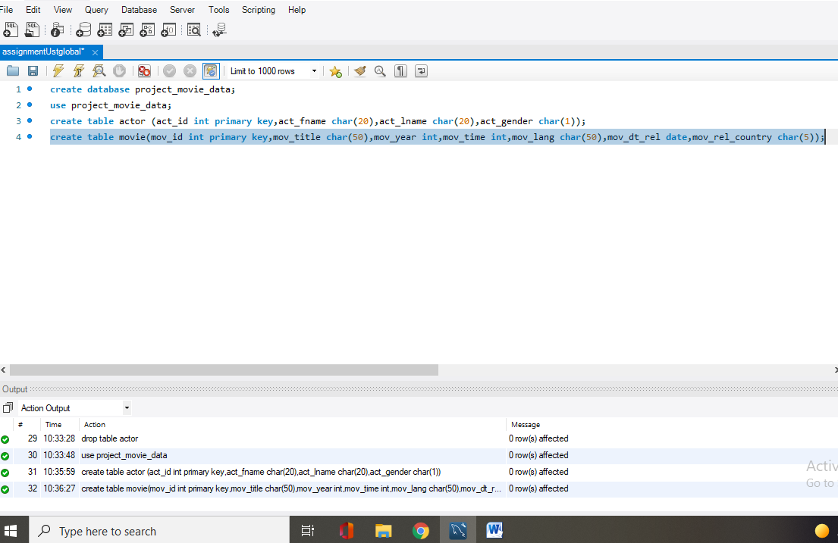 use project_movie_data;

**2. Create 9 tables which are presented in ER model and load the data with their foreign key**

**and primary key values.**

Ans: create table actor (act_id int primary key,act_fname char(20),act_lname char(20),act_gender char(1));

create table movie(mov_id int primary key,mov_title char(50),mov_year int,mov_time int,mov_lang char(50),mov_dt_rel date,mov_rel_country char(5));

create table movie_cast(act_id int ,mov_id int ,mov_role char(30), foreign key(act_id) references actor(act_id), foreign key(mov_id) references movie(mov_id));

create table director(dir_id int primary key,dir_fname char(20),dir_lname char(20));

create table movie_direction(dir_id int ,mov_id int ,foreign key(dir_id) references director(dir_id), foreign key(mov_id) references movie(mov_id));

create table reviewer(rev_id int primary key,rev_name char(30));

create table rating(mov_id int ,rev_id int,rev_stars int,num_o_ratings int,foreign key(mov_id) references movie(mov_id), foreign key(rev_id) references reviewer(rev_id));

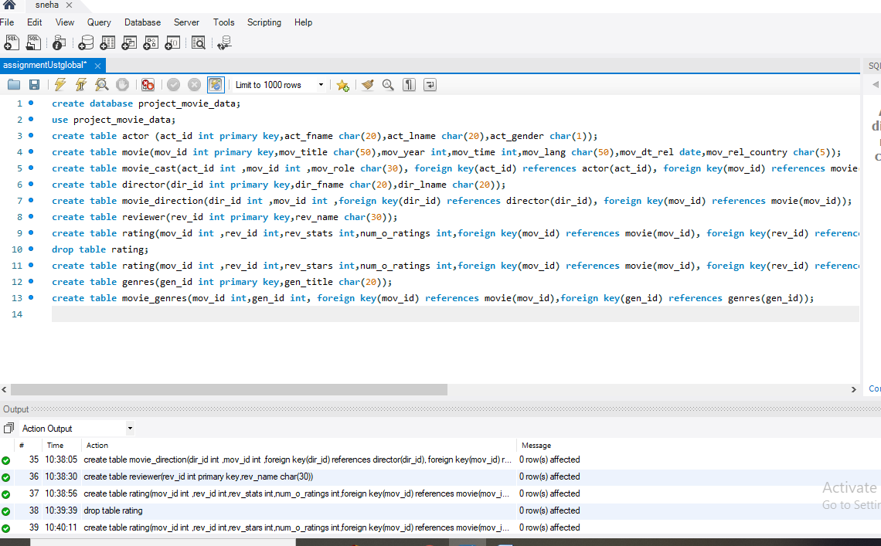

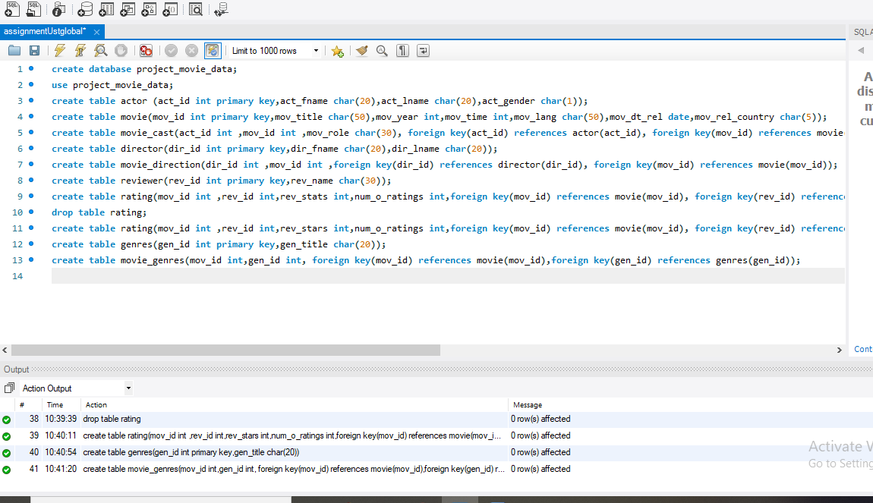

insert into actor(act_id,act_fname,act_lname,act_gender) values(101,"James","Stewart","M"),(102,"Deborah","kerr","F"),(103,"Peter","OToole","M"),(104,"Robers","De Niro","M");

insert into actor( act_id,act_fname,act_lname,act_gender) values(105,"F.murray","Abraham","M");

insert into actor(act_id,act_fname,act_lname,act_gender) values(106,"Harrison","Ford","M"),(107,"Nicale","kidman","F"),(108,"Stephon","Raldwin","M"),(109,"Jack","Nicholson","M"),(110,"Mack","Wahlberg","M");

insert into actor(act_id,act_fname,act_lname,act_gender) values(111,"Woody","Allen","M"),(112,"claire","Danes","F"),(113,"Tim","Robbins","M"),(114,"Kevin","Spacy","M"),(115,"Kate","Winslet","F");

insert into actor(act_id,act_fname,act_lname,act_gender) values(116,"Robin","Williams","F"),(117,"Jon","vaught","M"),(118,"Ewan","cGregor","M");

insert into actor(act_id,act_fname,act_lname,act_gender) values(119,"Christian","Eale","M"),(120,"Maggie","Gyllenhaal","F"),(121,"Dev","Patel","M"),(122,"Signurney","Weaver","F"),(123,"David","Aston","M"),(124,"Ali","Astin","F");

insert into movie(mov_id,mov_title,mov_year,mov_time,mov_lang,mov_dt_rel,mov_rel_country ) values(901,"Vertigo ",1958,128,"English",'1958-08-24',"Uk"),(902,"The Innocent ",1961,100,"English",'1962-02-19',"Sw"),(903,"Lawrence of Arabia ",1962,216,"English",'1962-12-11',"Uk"),(904,"The Deer Hunter ",1978,183,"English",'1979-03-08',"Uk");

insert into movie(mov_id,mov_title,mov_year,mov_time,mov_lang,mov_dt_rel,mov_rel_country ) values(905,"Amadeus ",1984,160,"English",'1985-01-07',"Uk");

insert into movie(mov_id,mov_title,mov_year,mov_time,mov_lang,mov_dt_rel,mov_rel_country ) values(906,"Blade Runner ",1982,117,"English",'1982-09-09',"Uk"),(907,"Eyes wide Shut ",1999,159,"English",null,"UK"),(908,"The Usual Suspects ",1995,106,"English",'1995-08-25',"Uk"),(909,"Chinatown",1974,130,"English",'1974-08-09',"Uk");

insert into movie(mov_id,mov_title,mov_year,mov_time,mov_lang,mov_dt_rel,mov_rel_country ) values(910,"Boogre Nights",1997,155,"English",'1998-02-16',"Uk"),(911,"Annie Hall",1977,93,"English",'1977-04-20',"USA"),(912,"princess Mononoke ",1997,134,"Japanese",'2001-10-19',"Uk"),(913,"The Shawhank Redemption",1994,142,"English",'1995-02-17',"Uk"),(914,"American Beauty",1999,122,"English",null,"Uk");

insert into movie(mov_id,mov_title,mov_year,mov_time,mov_lang,mov_dt_rel,mov_rel_country ) values(915,"Titanic",1997,194,"English",'1998-01-23',"Uk"),(916,"Good Will Hunting",1977,93,"English",'1977-04-20',"USA"),(917,"Deliverance ",1972,109,"English",'1982-10-05',"Uk"),(918,"Trainspotting",1996,94,"English",'1996-02-23',"Uk"),(919,"The prestige",2006,130,"English",'2006-11-10',"Uk");

insert into movie(mov_id,mov_title,mov_year,mov_time,mov_lang,mov_dt_rel,mov_rel_country ) values(920,"Donnie Darko",2001,113,"English",null,"Uk"),(921,"Slumdog illionaire",2008,120,"English",'2009-01-09',"UK"),(922,"Aliens",1986,137,"English",'1986-08-29',"Uk"),(923,"Beyond the Sea",2004,118,"English",'2004-11-26',"Uk"),(924,"Avatar",2009,162,"English",'2009-12-17',"Uk");

insert into movie(mov_id,mov_title,mov_year,mov_time,mov_lang,mov_dt_rel,mov_rel_country ) values(926,"Seven Samutai",1954,207,"Japanese",'1954-04-26',"IP"),(927,"Spirited Away",2001,125,"Japanese",'2003-09-12',"UK"),(928,"Back to the Future",1985,116,"English",'1985-12-04',"Uk"),(925,"Braveheart",1995,178,"English",'1995-09-08',"Uk");

insert into movie_cast(act_id,mov_id,mov_role ) values(101,901,"John Scottie Ferguson");

insert into movie_cast(act_id,mov_id,mov_role ) values(102,902,"Miss Giddens ");

insert into movie_cast(act_id,mov_id,mov_role ) values(103,903,"T.E Lawrence");

insert into movie_cast(act_id,mov_id,mov_role ) values(104,904,"Michael");

insert into movie_cast(act_id,mov_id,mov_role ) values(105,905,"AntonioSalieri");

insert into movie_cast(act_id,mov_id,mov_role ) values(106,906,"Rick Deckard");

insert into movie_cast(act_id,mov_id,mov_role ) values(107,907,"Alice Harford");

insert into movie_cast(act_id,mov_id,mov_role ) values(108,908,"McManus"),(110,910,"Eddie Adams"),(111,911,"Alvy Singer"),(112,912,"San"),(113,913,"Andy Dufresne"),(114,914,"Lester Burnham"),(115,915,"Rose DeWitt Bukater");

insert into movie_cast(act_id,mov_id,mov_role ) values(116,916,"Sean Maguire"),(117,917,"Ed"),(118,918,"Renton"),(120,920,"Elizabeth Darko"),(121,921,"Older Jamal"),(122,922,"Ripley"),(114,923,"Bobby Darin"),(109,909,"J.J Gittes"),(119,919,"Alfred Borden");

insert into director(dir_id,dir_fname,dir_lname ) values(201,"Alfred","Hitchcock"),(202,"Jack","Clayton"),(203,"David","Lean"),(204,"Michael","Cimino"),(205,"Milos","Forman"),(206,"Ridley","Scott"),(207,"Stanley","Singer"),(208,"Bryan","Singer"),(209,"Roman","olanski"),(210,"Paul","Thomas Anderson"),(211,"Woody","Allen");

insert into director(dir_id,dir_fname,dir_lname ) values(212,"Hayao","Niyazaki"),(213,"Frank","Darabont"),(214,"Sam","Mendes"),(215,"James","Cameron"),(216,"Gus","Vansant"),(217,"John","Boorman"),(218,"Danny","Boyle"),(219,"Christopher","Nolan"),(220,"Richard","Kelly"),(221,"Kevin","Spacey"),(222,"Andrei","Tarkovsky"),(223,"Peta","Jackson");

insert into movie_direction(dir_id,mov_id ) values(201,901),(202,901),(203,903),(204,904),(205,905),(206,906),(207,907),(208,908),(209,909),(210,910),(211,911),(212,912),(213,913),(214,914),(215,915),(216,916),(217,917),(218,918),(219,919),(220,920),(218,921),(215,922),(221,923);

insert into reviewer(rev_id,rev_name ) values(9001,"Righty Sock"),(9002,"Jack Malvern"),(9003,"Flagrant Baronessa"),(9004,"Alec Shaw"),(9005,null),(9006,"Victor Woeltjen"),(9007,"Simon Wright"),(9008,"Neal Wruck"),(9009,"Paul Monks"),(9010,"Mike Salvati"),(9011,null),(9012,"Wesley S.Walker"),(9013,"Sasha Golgshtein"),(9014,"Josh Cates"),(9015,"Krug Stillo"),(9016,"Scott LeBrun"),(9017,"Hannah Steele"),(9018,"Vincent Cadena"),(9019,"Brand Sponseller"),(9020,"Richard Adams");

insert into rating(mov_id,rev_id,rev_stars,num_o_ratings ) values(901,9001,8.4,263575),(902,9002,7.9,20207),(903,9003,8.3,202778),(906,9005,8.2,484746),(924,9006,7.3,null),(908,9007,8.6,779489),(909,9008,null,227235),(910,9009,3,195961),(911,9010,8.1,203875),(912,9011,8.4,null),(914,9013,7,862618),(915,9001,7.7,830095),(916,9014,4,642132);

insert into rating(mov_id,rev_id,rev_stars,num_o_ratings ) values(925,9015,7.7,81328),(918,9015,null,580301),(920,9017,8.1,609451),(921,9018,8,667758),(922,9019,8.4,511613),(923,9020,6.7,13091);

insert into genres(gen_id,gen_title ) values(1001,"Action"),(1002,"Adventure"),(1003,"Animation"),(1004,"Biography"),(1005,"Comedy"),(1006,"Crime"),(1007,"Drama"),(1008,"Horror"),(1009,"Music"),(1010,"Mystery"),(1011,"Romance"),(1012,"Triller"),(1013,"War");

insert into movie_genres(mov_id,gen_id ) values(922,1001),(917,1002),(903,1002),(912,1003),(911,1005),(908,1006),(913,1006),(926,1007),(928,1007),(918,1007),(921,1007),(902,1008),(907,1010),(927,1010),(901,1010),(914,1011),(906,1012),(904,1013);

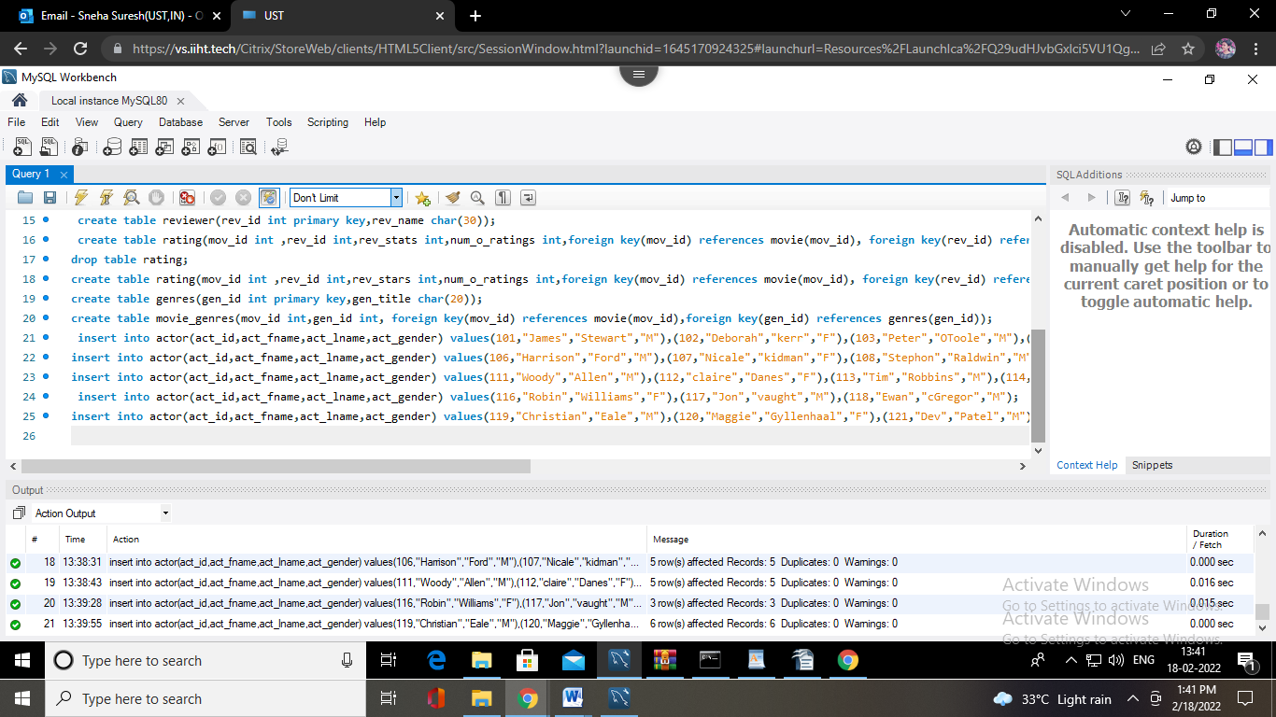

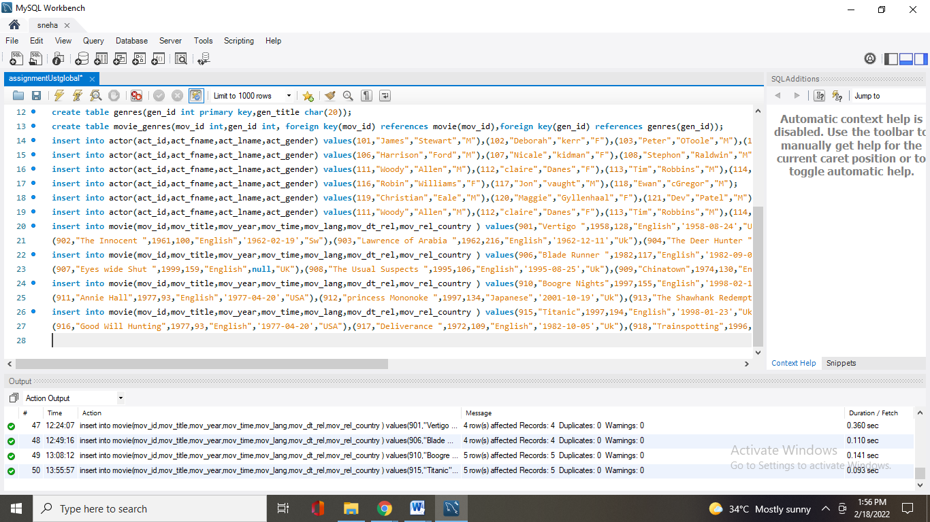

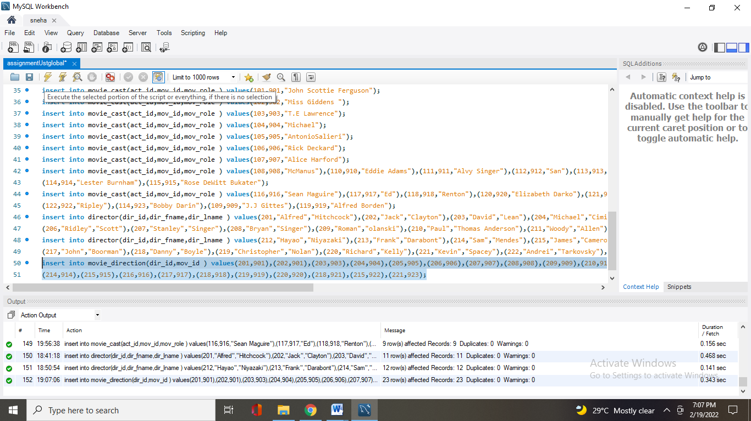

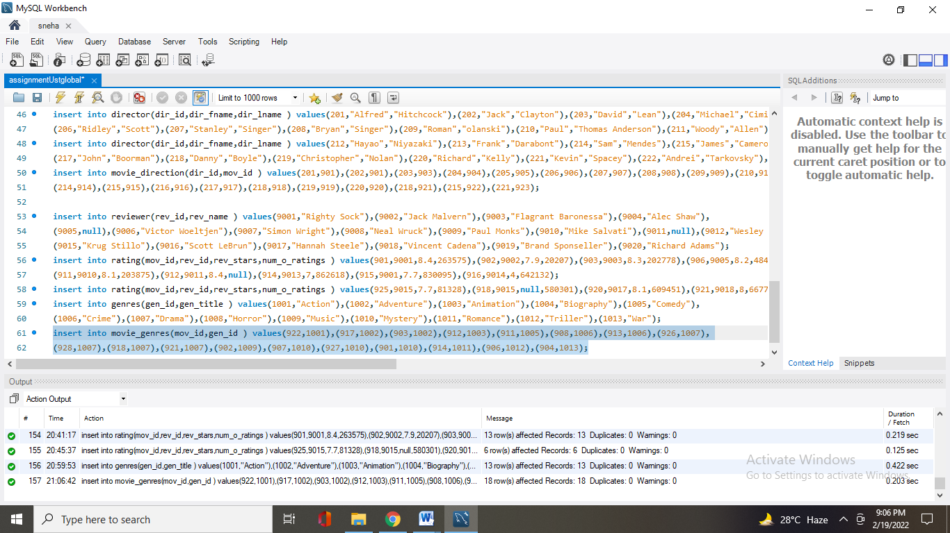

**3.Write a query in SQL to list the Horror movies?**

Ans: select mov_title from movie where mov_id in (select mov_id from movie_genres where gen_id in (select gen_id from genres where gen_title="Horror"));

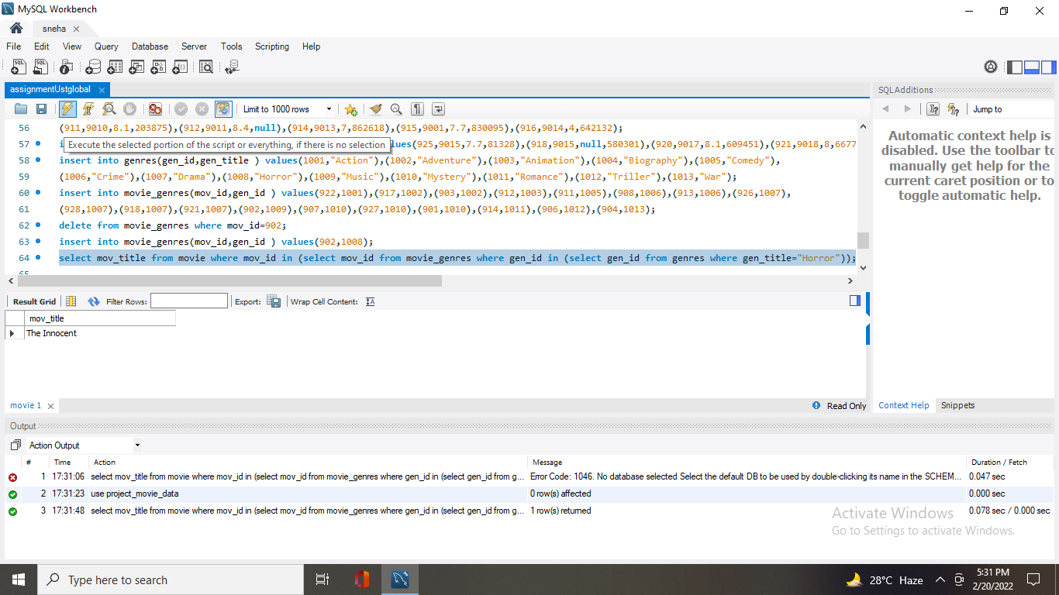

**4. Write a query in SQL to find the name of all reviewers who have rated 8 or more stars**

Ans: select rev_name from reviewer where rev_id in (select rev_id from rating where rev_stars >=8 );

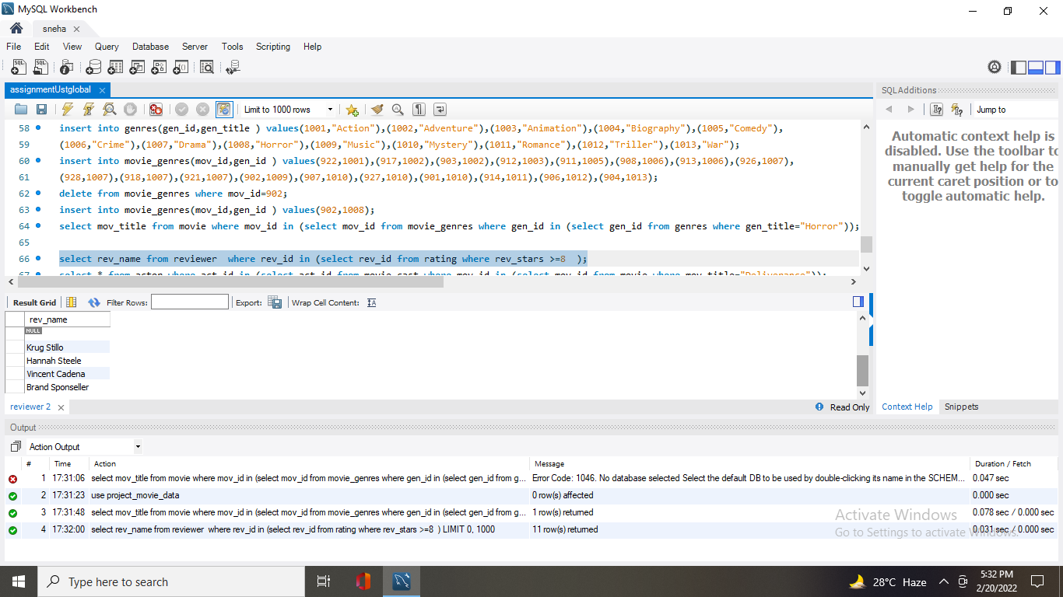

**5. Write a query in SQL to list all the information of the actors who played a role in the movie**

**‘Deliverance’.**

Ans: select * from actor where act_id in (select act_id from movie_cast where mov_id in (select mov_id from movie where mov_title="Deliverance"));

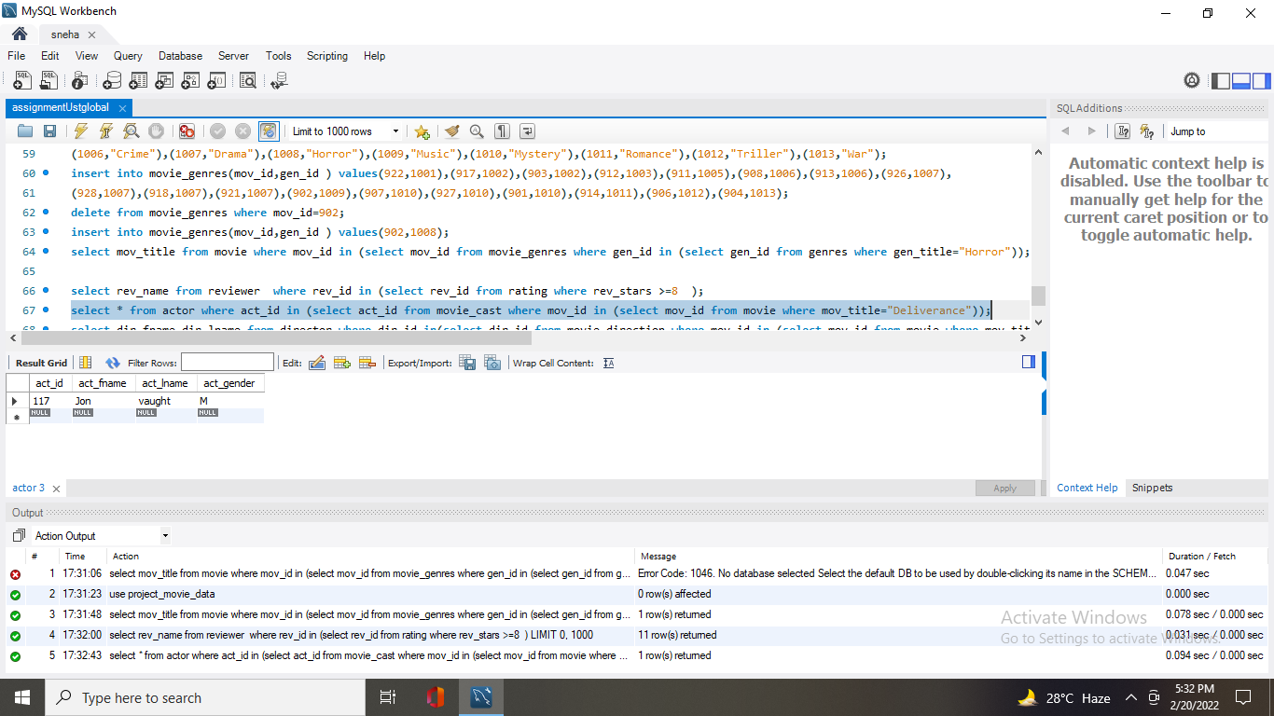

**6. Write a query in SQL to find the name of the director (first and last names) who directed a**

**movie that casted a role for ‘Eyes Wide Shut’. (using subquery)**

Ans: select dir_fname,dir_lname from director where dir_id in(select dir_id from movie_direction where mov_id in (select mov_id from movie where mov_title="Eyes wide shut"));

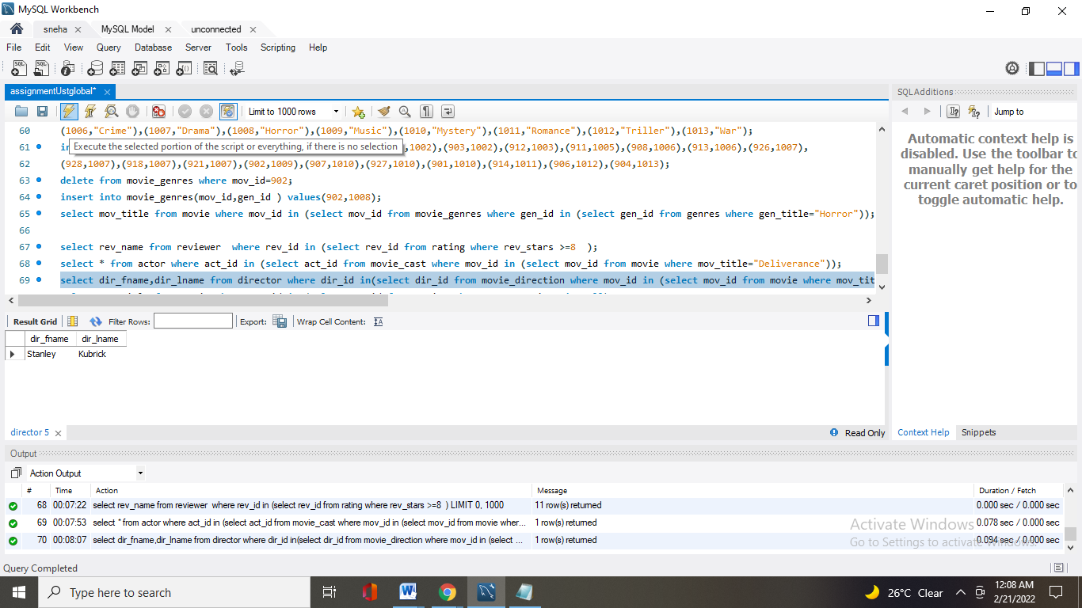

**7. Write a query in SQL to find the movie title, year, date of release, director and actor for**

**those movies which reviewer is ‘Neal Wruck’.**

Ans: select dir_fname,dir_lname from director where dir_id in(select dir_id from movie_direction where mov_id in (select mov_id from movie where mov_title="Eyes wide shut"));

